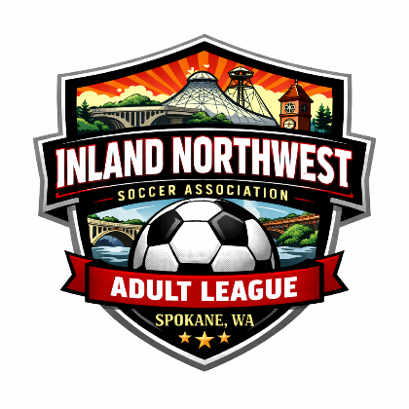
INSA - PLAYER CODE OF CONDUCT

Inland Northwest Soccer Association
PO Box 40226 Spokane, WA 99220
admin@inlandnorthwestsoccer.com
www.inlandnorthwestsoccer.com

I will conduct myself with honor, dignity and treat other players as I would like to be treated. I will remember at all times that I am representing the Inland Northwest Soccer Association, my team, and my community. I will respect the authority of the referee, even though I may disagree with the call. I will obey the laws of the game and play within the spirit of the laws. If I don't understand the laws, I will attempt to learn them so I can become a better player. (Males) For Co-Ed leagues, in consideration of social standards and size disparity, I will respect the safety of all female athletes and play as a gentleman at all times. I will control my temper. I will not assault others or use foul or abusive language or inappropriate gestures. I will treat other players, coaches, officials, and fans with respect regardless of race, sex, sexual orientation, or ability, and I will expect to be treated accordingly. I will not, under any circumstances, participate in physical violence or threats of physical violence before, during or after any game. I will demonstrate fair play and good sportsmanship at every game and tournament. I will also encourage fair play and good sportsmanship from other players, coaches, and officials. I will remember that winning isn't everything, that having fun, playing fair, improving my skills, making friends, and giving my best efforts are the most important aspects of soccer. I will do the best I can each day, remembering that all players have talents and weaknesses, the same as I do. I will be modest and respectful when I win, and gracious when I lose. I will acknowledge all good play - that of my teammates and of my opponents. I consider it a privilege to be a part of US Club Soccer and my actions will reflect credit upon that organization and its affiliates. Remember the actions of yourself and your team is reflective of the perception others take away with them. Persons bound by this Code shall show commitment to an ethical attitude. They shall behave in a dignified manner and act with complete credibility and integrity.

Player's Name:

Player's Signature:

Date:

